**Creating of container (blob storage)**

It's designed to store and retrieve large amounts of unstructured data, such as text, images, videos, and audio files.

Azure blob storage is basically three types

* Block blob
* Append blob
* Page blob

**Types:**

* **Block Blobs:** Primarily designed for storing unstructured data like images, videos, and large files.

Block blobs are made up of individual blocks of data. These blocks are then grouped together to form a single blob.

That means block blobs stores the data in the form blocks.

 A block blob can include or store up to **50,000** blocks.

Each block in a block blob can be a different size, up to the maximum size permitted for the service version in use.

|  |  |  |
| --- | --- | --- |
| **Service version** | **Max block size** | **Max blob size** |
| Version 2019-12-12 and later | 4000MB | ~190.7TB |
| Version 2016-05-31 through version 2019-07-07 | 100MB | ~4.75TB |
| Version previous to 2016-05-31 | 4MB | ~195TB |

Here each block can be identified by the Block ID.

**Features:**

It can store unstructured data like images, files, audio, and video & so on…

You can modify individual blocks within a blob without affecting the entire blob.

You can easily upload or modify individual blocks within a block blob without affecting the entire blob.

Well-suited for streaming scenarios where data is uploaded or downloaded sequentially.

Block blobs can scale to very large sizes (up to 5 TB), making them suitable for storing large files.

Block blobs can store files up to 4.75 TB in size, making them ideal for large media files, backups, and other large datasets.

Block blobs can be uploaded and downloaded in parallel, improving transfer speeds for large files.

* + - **Append Blobs:**

In Azure Storage, Append Blobs are a specialized type of blob designed for efficiently appending (adding) data to existing blobs.

That means it is ideal for scenarios where data is written in a stream or appended (added) to existing data.

Append blobs are composed of blocks, similar to block blobs, but with a focus on efficient append operations.

Appending data is a fast and efficient operation, as new data is simply added to the end of the existing blob content.

**Note:** You cannot modify or delete existing blocks within an append blob. Only new data can be appended. That means Updating or deleting of existing blocks is not supported.

Each block in an append blob can be a different size, up to a maximum of 4 MB. And an append blob can include up to 50,000 blocks.

The maximum size of an append blob is therefore slightly more than 195 GB (4 MB X 50,000 blocks).

* + - **Page Blobs:**

In Azure Storage, Page Blobs are a specialized type of blob designed for storing and managing large, random-access files.

Page Blobs allow you to read and write specific portions of the blob data directly, without having to deal with individual blocks.

Page Blobs are composed of 512-byte pages, enabling efficient random access and updates to specific parts of the data.

Commonly used to store Virtual Hard Disks (VHDs) for Azure Virtual Machines. This allows for efficient operation of the virtual machine's operating system and applications.

The maximum page blob size is 8TB. Each page size is 512-bytes.

Let’s create the azure container (blob storage) in storage account.

Step1: create resource group. (RG-1)

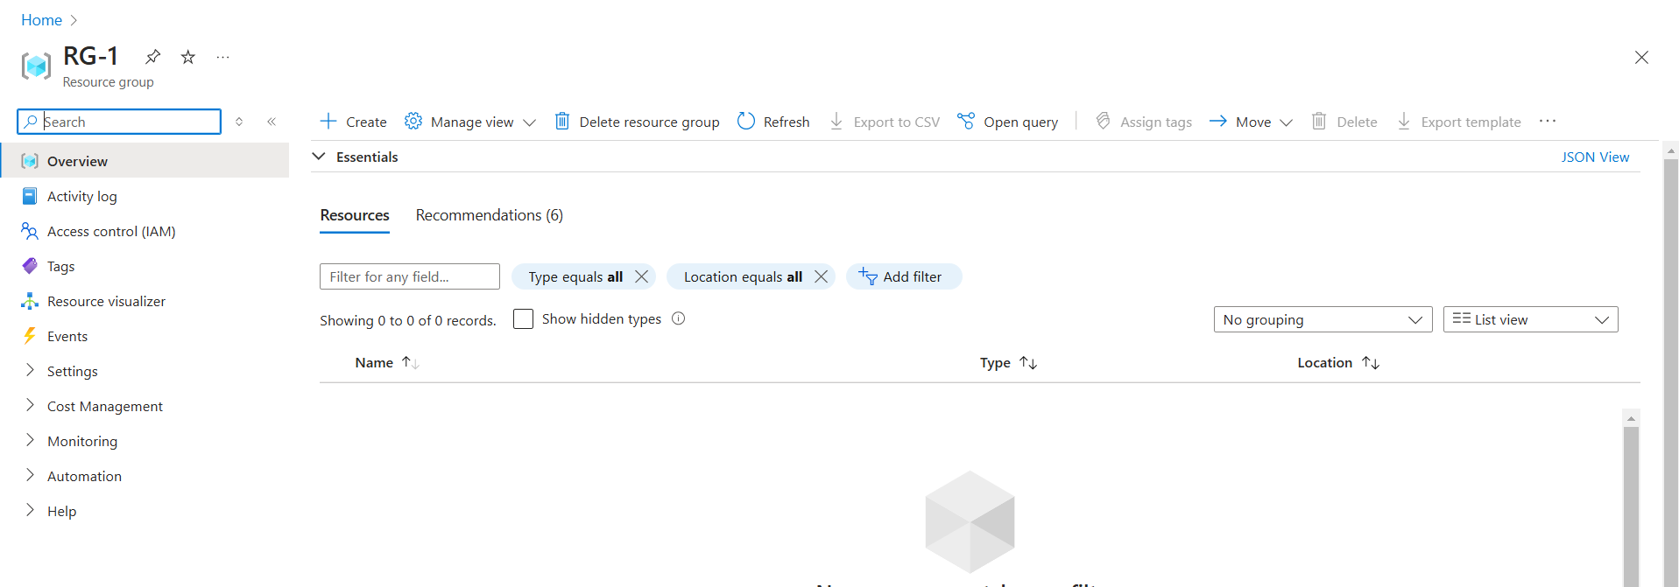

Step2: create the storage account. (“myfirststorageaccount978”).

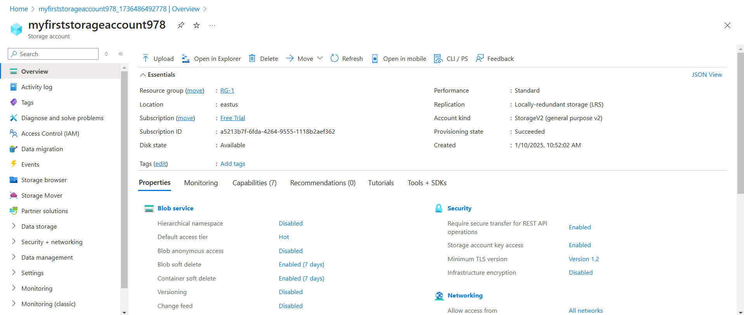

**Note:** In order to make our container or blob in public we have to enable anonymous access

Go to🡪settings🡪configuration🡪 Allow Blob anonymous access

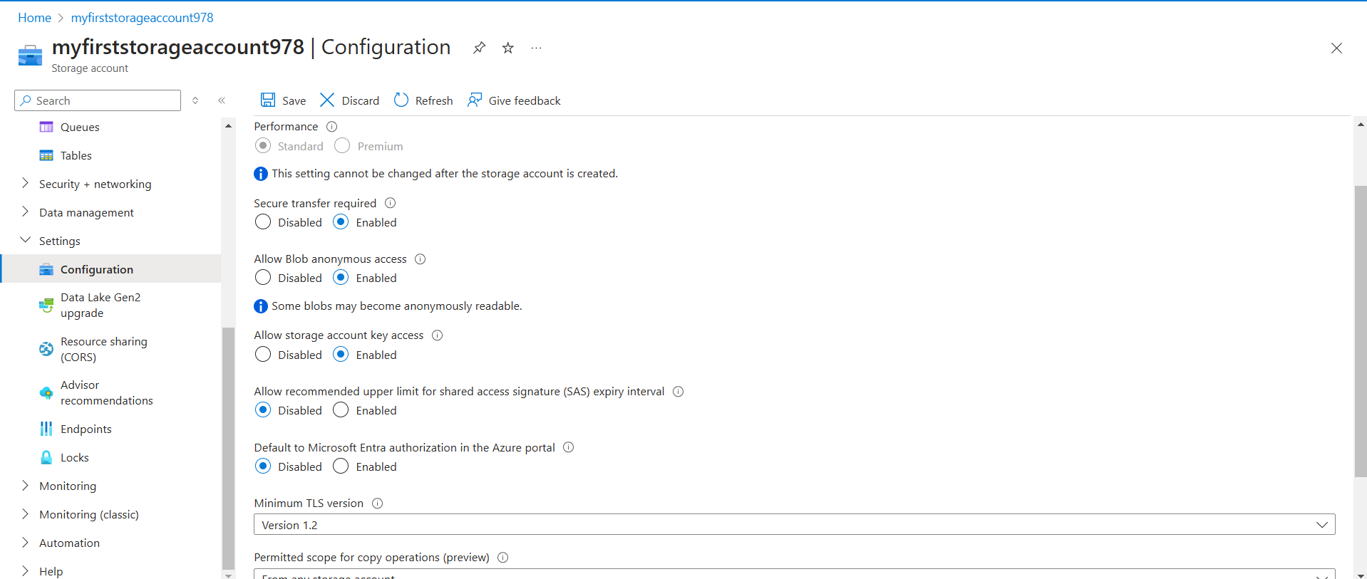

Step3: Now create the container. (harishcn-1).

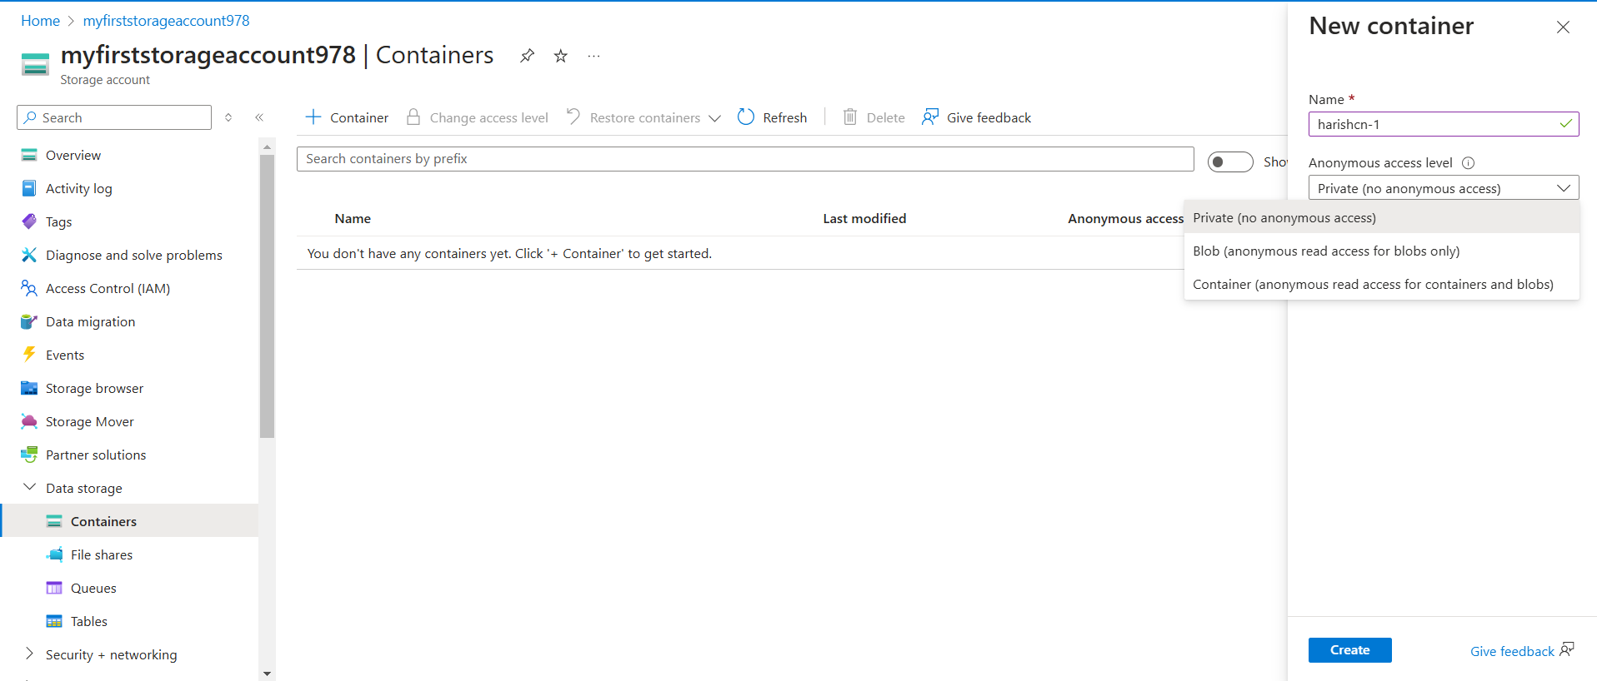

**Fig**: container Anonymous access level.

Step4: let’s create the container by Anonymous access as Private.

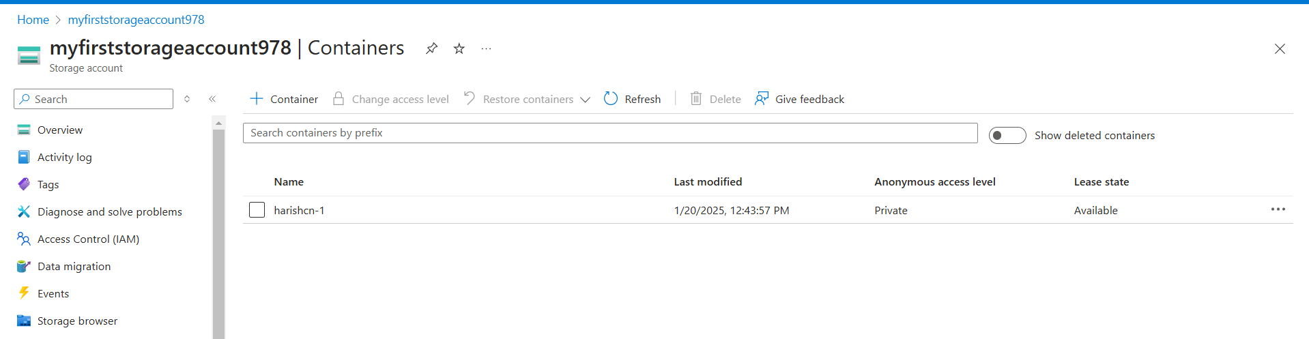

Step5: Upload any image or file in this container.

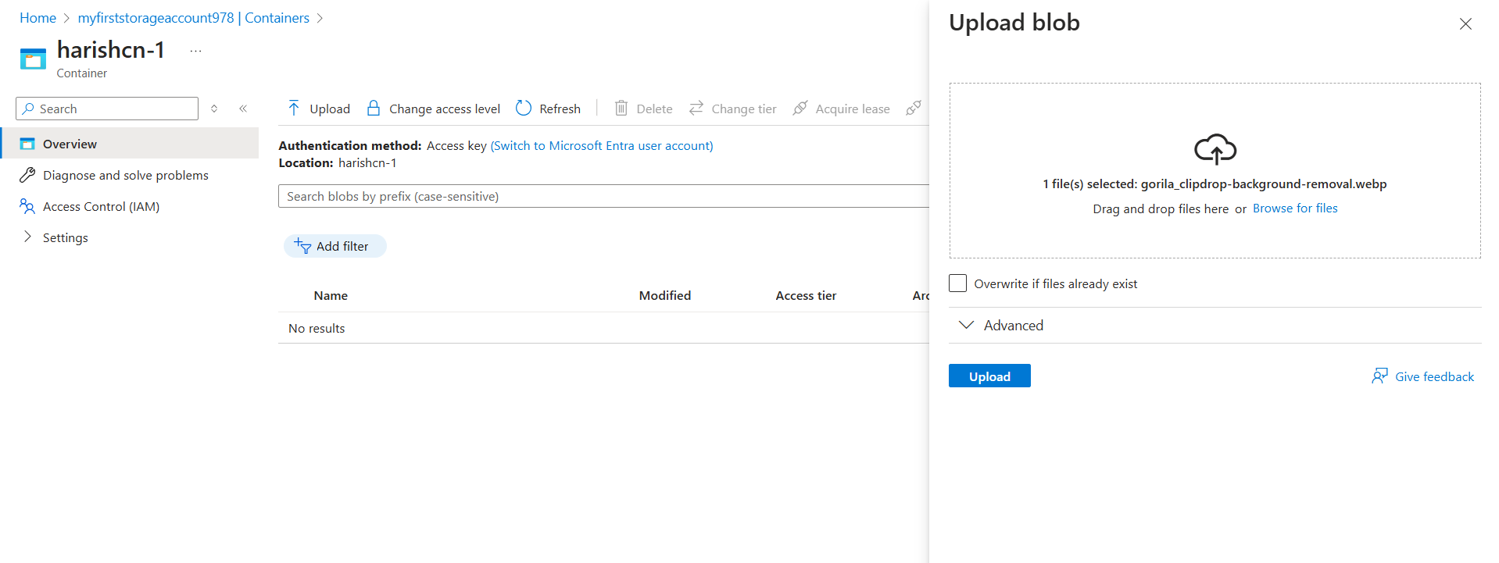

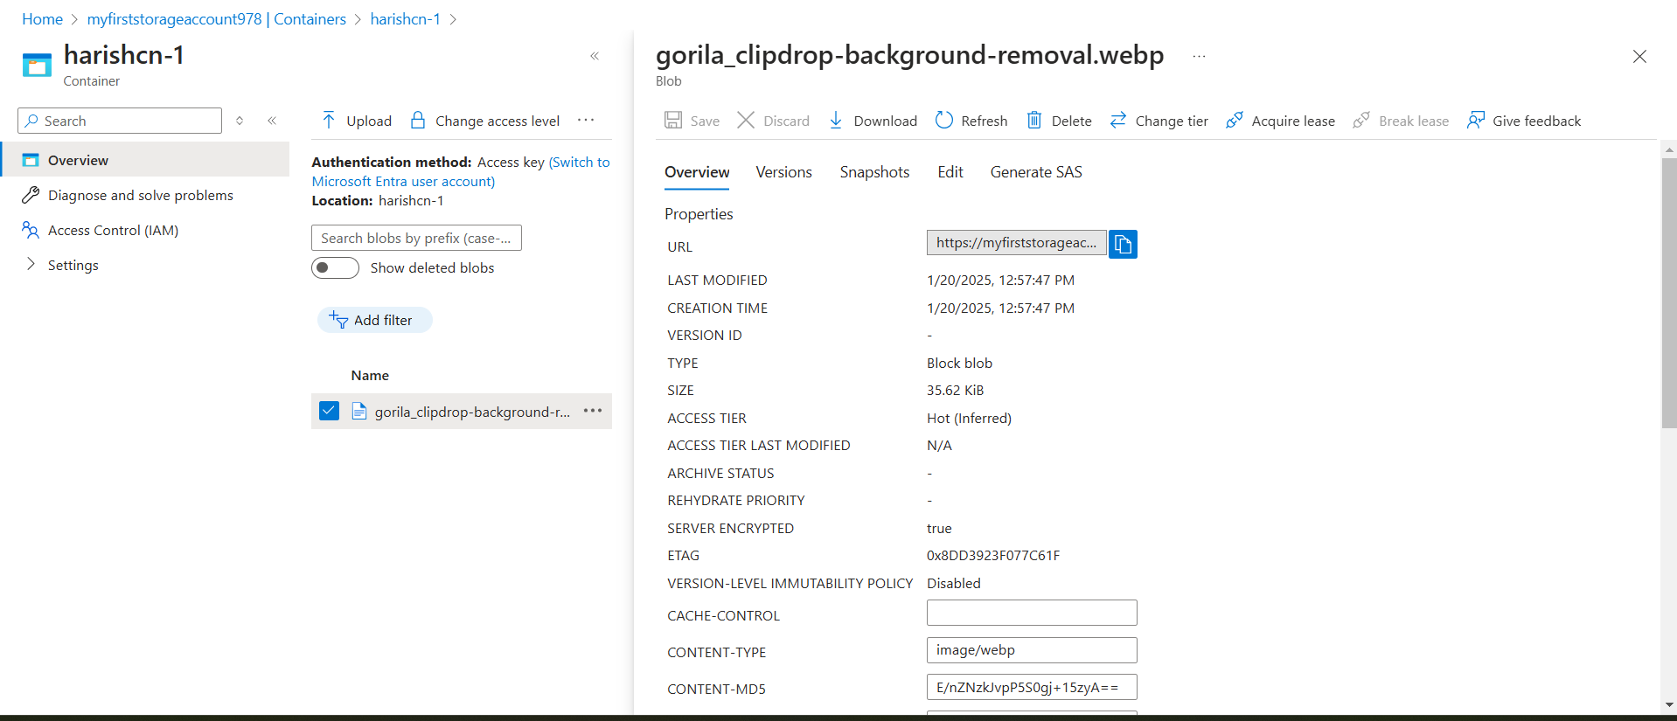

Copy the URL and brows in any browser it cannot show the image or file as its anonymous access is private.

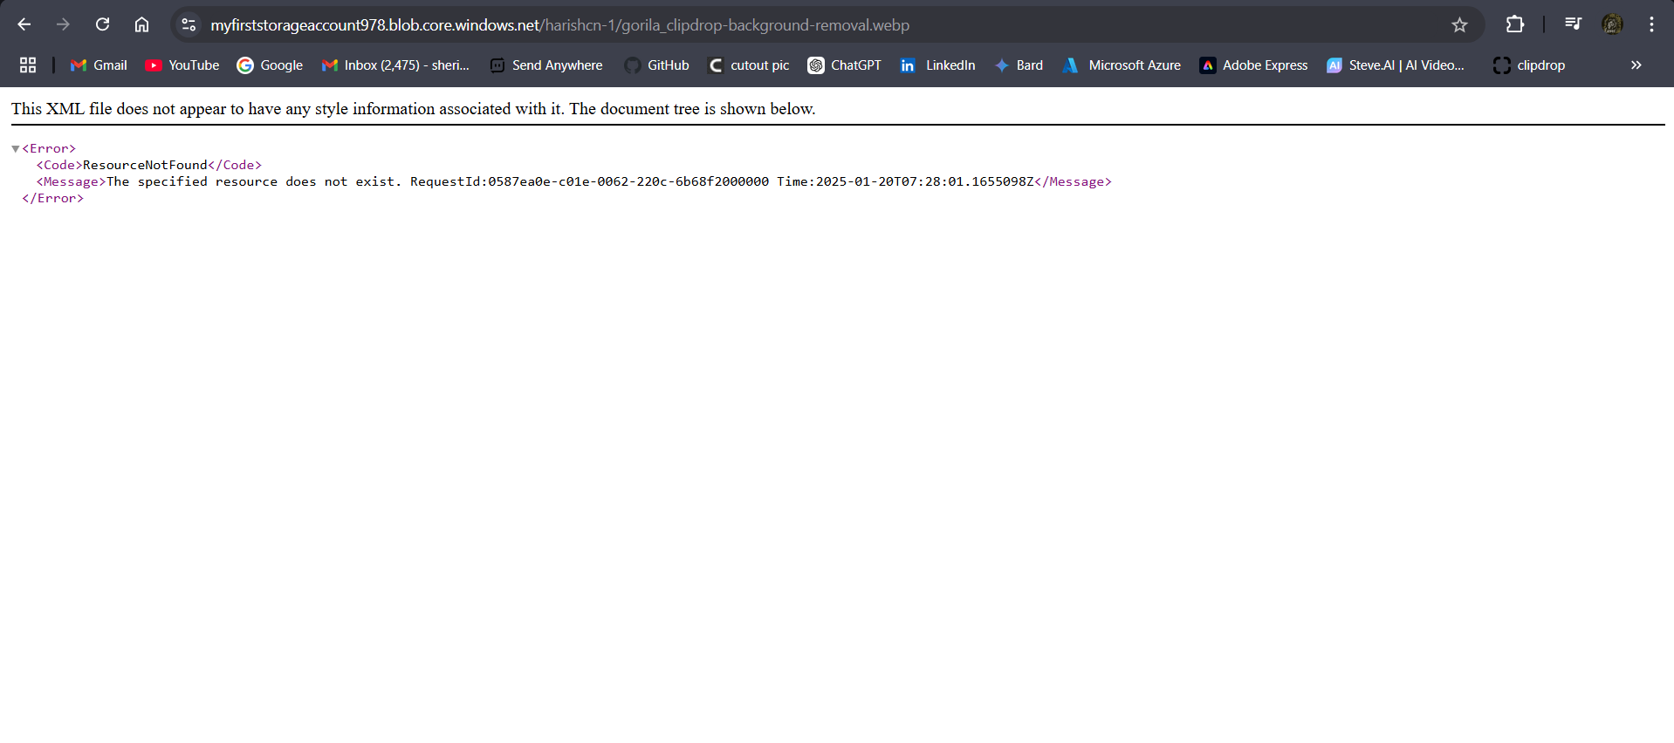

Step5: Do the above process by keeping Anonymous Access as Blob (anonymous read access for blob only) and container (anonymous read access for containers and blobs.).

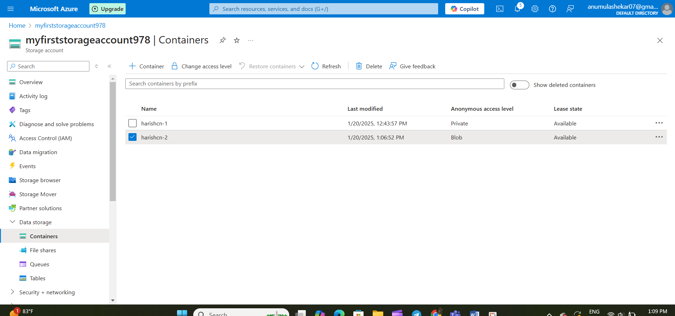

**Fig**: container “**harishcn-2**” with anonymous access as “**blob”**



**Fig:** image is live when we Brows URL in any browser.

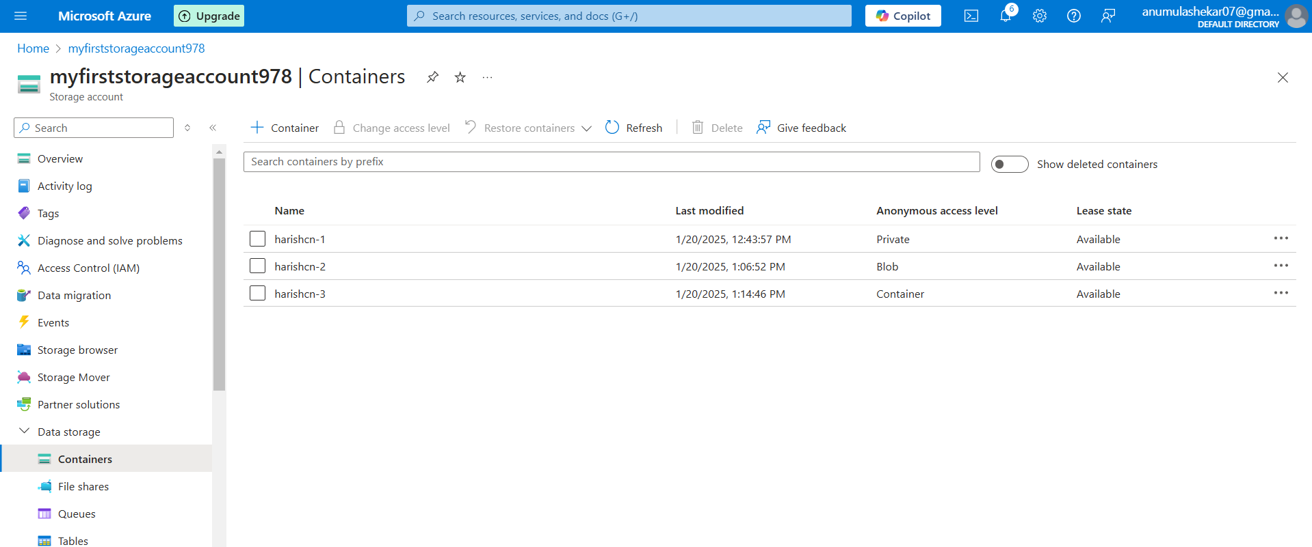

**Fig:** container “harishcn-3” with anonymous access as “container”.



**Fig:** image is live when we brows using URL of container.

**The difference between the blob and container level Anonymous access in storage account.**

**Key Differences between Blob and Container Level Anonymous Access in Azure Storage**

|  |  |  |
| --- | --- | --- |
| **Feature** | **Blob Level** | **Container Level** |
| **Scope** | Grants anonymous access to **specific blobs** within a container. | Grants anonymous access to **all blobs** within a container. |
| **Granularity** | More fine-grained control over which data is publicly accessible. | Less granular, as it affects all blobs in the container. |
| **Security** | Generally considered more secure as it limits public exposure to only necessary blobs. | Potentially less secure if sensitive data is stored within the same container. |
| **Configuration** | Requires explicit configuration for each individual blob. | Configured at the container level, affecting all blobs within. |
| **Use Cases** | Suitable for scenarios where only specific files need to be publicly accessible, such as images for a website or downloadable documents. | Appropriate when all blobs within a container should be accessible to the public, such as a collection of public domain images. |

* **Blob-level anonymous access** offers more control and security by allowing you to selectively expose specific blobs.
* **Container-level anonymous access** provides broader access to all blobs within a container, which can be convenient but may pose greater security risks.

**Note**: In both blob and container level anonymous access we can view and brows the image or file. But the difference is in blob level we cannot list the images or files. In Container level we can list the images or files. (Using prefix URL:?restype=container&comp=list).

Ex: <https://myfirststorageaccount978.blob.core.windows.net/harishcn-3?restype=container&comp=list>

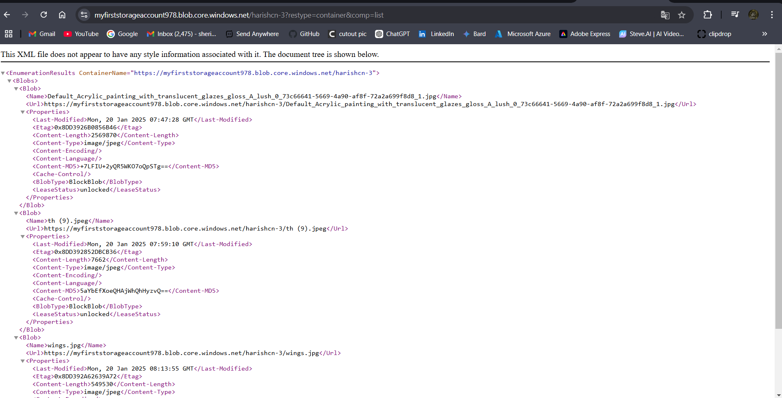

**Note:** By using azure storage account we can host or deploy only static websites not the dynamic websites.

**Hosting of static Website in Blob container**

Step1: create a storage account.



Step2: go to “data management” then enable the static Website.

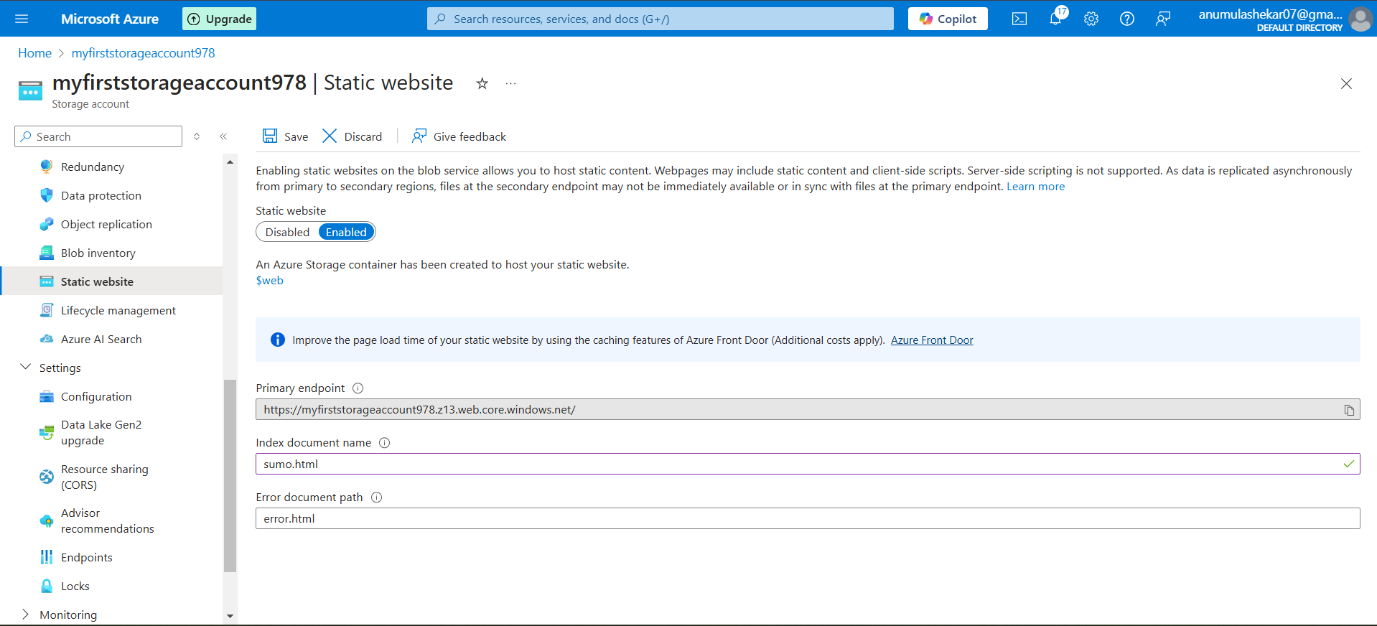

Step3: now go to the containers open the $web container and upload your static website.

**Note:** $web is creates while creating the static website.

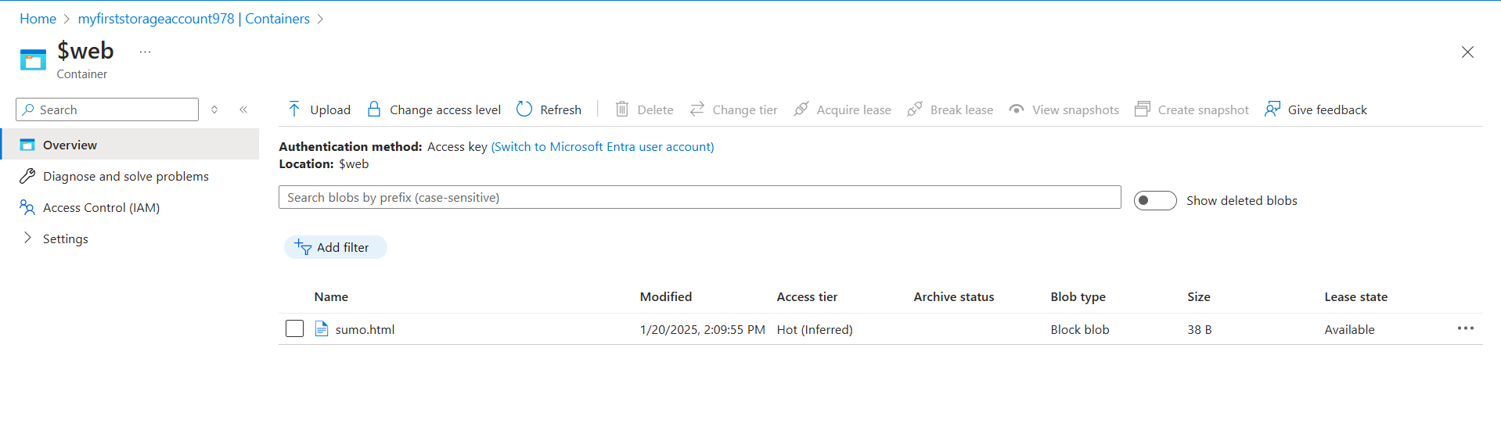

Step4: copy the primary end point from static website button. And brows it in any browser.

